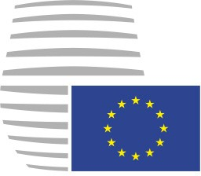
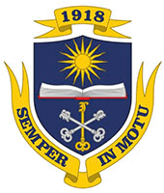

European Council Model

Voronezh, 1 November 2017 (OR. en)
EUCO 1/17

COVER NOTE
From: European Council
To: Delegations
Subject: European Council meeting (1 November 2017)
– Conclusions

Delegations will find attached the conclusions adopted by the European Council at the above meeting.

At the start of the meeting, the Member of the European Council representing the Member State provided an overview of progress on the implementation of earlier European Council conclusions.

MIGRATION

  - The European Council understands the importance and urgency of solving the migration problem for the international community.
  - The European Council calls for close monitoring of the situation along the Eastern and Western Mediterranean routes in light of recent increases in migration flows.
  - The European Council encourages the European community to discharge the responsibilities and previously agreed arrangements upon the migration flow issue.
  - The European Council encourages the willingness of the European Union member states to accept immigrants, thereby demonstrating Europe's direction towards the Sustainable Development Goals.

  - The European Council welcomes the progress achieved so far on the reform of the Common European Asylum System and calls for further convergence towards an agreement which strikes the right balance between responsibility and solidarity and ensures resilience to future crises, in line with its June 2017 conclusions. The European Council will return to this matter at its meeting in December, and will seek to reach a consensus during the first half of 2018.

- The European Council has decided to allocate 50 000 immigrants from Syrian Arab Republic among the European countries in the following proportions:
- Austria to host 5000 immigrants
- France to host 8000 immigrants
- Germany to host 11500 immigrants
- Italy to host 15000 immigrants
- Portugal to host 11000 immigrants
- Spain to host 11000 immigrants

- The European Council regret profoundly that the delegation of the United Kingdom and Northern Ireland is not able to host any immigrants due to the withdrawal from the European Union.

